LVKC December Point Show 2019
BREED AND OBEDIENCE TROPHY PLEDGES
(Deadline: AUGUST 10TH 2019)

It's time to show your SUPPORT for the Lehigh Valley Kennel Club and your breed with a trophy pledge or two.

This year I have selected a Portable Dog Bowl. Great for going to shows or traveling. Can be used for water or food. The cost is $4.00.

If you would prefer to select your own trophy, please fill out the pledge sheet and return it to me so I have a record of your selection.

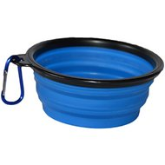

I HEREBY AGREE TO PLEDGE or OFFER THE FOLLOWING TROPHIES:

Placing:

Trophy:

Placing:

Trophy:

Amount Enclosed: $ (make checks payable to LVKC)
Your name: Kennel:
Address:
Phone: Signature:

AKC rules state "Donors of trophies must state a value or define as follows: sterling silver, silver-plated, bronze, copper, etc.”

Mail trophies and pledges to:
Bobbie Dunkling 610 435-5897
4338 Clear Way autumnsno2@gmail.com
Allentown, PA 18103

