2019 LVKC ANNUAL AWARDS APPLICATION
Please complete the following application carefully and neatly. You must use one application form for each award (even if the same dog earned more than one trophy!!) Refer to “Rules” to confirm your eligibility for an award, and the type of awards honored. Titles/Degrees must have been earned in 2018.

Name(s): Phone:

Address: e-mail:

City: State: Zip Code:

The following AKC registered, purebred dog received the following Title/Degree:

AKC Title/Degree:

Dog's Registered Name & Call name: Did this dog receive a plaque for a title in the past? What title & year.

Dog's Breed: AKC Number:

Date Title/Degree Completed:

Remember: If you already received a plaque for this dog’s accomplishments, you will not get another plaque. You will get a brass plate for each title, inscribed with the AKC Award earned. The brass plates can be attached to the plaque you already have.

*Please list the Dates of at least 2 meetings you attended in ‘18____________________

*List two functions at which you volunteered in ’18____________________________

For ease in verification of information, please provide a copy of original AKC certificate.
Along with your application please send a photo and the Information Request form included in the BARKS. This is very important as Bodil plans to do a short presentation on each award winner. Your picture will be returned at the Awards Ceremony.

Send the completed application, photo and your information form(s) to:

Bodil Aczel, 1380 Masi Road, Quakertown, PA 18951
E-mail: bodilaczel@yahoo.com questions? Call – 215-536-8884

ABSOLUTE DEADLINE: FEBRUARY 15, 2019
Remember, you must complete ONE application for EACH award!!

LVKC ANNUAL AWARDS ELIGIBILITY AND RULES

1. Applicant must have been a Club member for one year and be in good standing with the LVKC and the AKC.
2. Membership starts on the date of the regular meeting at which the Club so voted.
3. Applicant must have attended two club meetings (other than the Christmas party or Awards Ceremony) within the year and volunteered at two club functions with the year according to the attendance records of the Recording Secretary.
4. Co-owners and Co-breeders (member/member or member/non-member) are eligible; however, only one award per dog category will be presented. Applicants opting to apply for a joint award should indicate this on the application form.
5. The award year runs from January 1 to December 31 of each year. Awards are presented in April for the preceding year. Awards applications must be submitted to and verified by the Awards Chairperson/Club Secretary by one of the following:

- Copy of Original AKC Certificate (preferred method)
- Date of Gazette in which Title/Degree was published
- List of shows at which points or legs were earned.

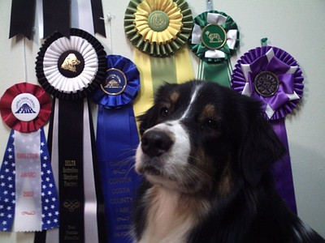

2019 LVKC Awards Ceremony Information Request Form

Please complete the following questionnaire to help me prepare a brief narrative to use along

with this year’s award presentation. If you do not have all the information or you do not wish to answer some of the questions, please fill in what you can.

1. How long have you been involved with this Breed?________________________________
2. Is this the first title you have earned? If not, how many have you earned?________
3. Are you the breeder of this dog?__________________________ (have you applied for the Breeder Of Champion award?- that must be on a separate form)
4. Call name of dog?____________Gender of the dog? Dog’s age, at receiving title?______
5. Where did the dog receive the needed qualifications for this title?

6. Has the dog received any special recognition/awards along the way?

7. Were there any special moments or rewarding events in achieving this title?

Please include any additional information you feel would be interesting for the presentation.

Would you like to say a few words when receiving your award(s)?
Yes,______ I would love to brag - a little!
No, ______ I would prefer to just smile and accept the award.

